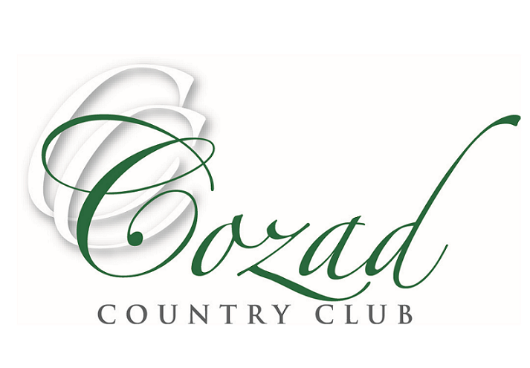
2024 Golf Tournament Schedule

May 18th: Cozad Chamber & CCC Fundraiser
June 1st & 2nd: Service Drug Memorial Tournament
4 Person Scramble ~ Calcutta Saturday Night
June 8th: Club Tournament
June 15th: Paulsen Employee Appreciation
June 16th: Father Son/Daughter
June 29th: Ducks Unlimited Tournament
4 Person Scramble
July 13th & 14th: Haymaker Open
Stroke Play ~ Calcutta Saturday Night
July 16th: CNSGA Seniors Tournament
July 26th: Waypoint Customer Appreciation
4 Person Scramble
July 27th: Football Booster
4 Person Scramble
August 3rd: Camp Comeca Tournament
4 Person Scramble
August 10th: Tim Thramer Memorial Tournament
4 Person Scramble
August 17th: Over/Under Tournament
2 Person Scramble ~ One player over 50 years of age, One under 50
August 24th & 25th: Maker Cup
September 6th: Cozad Alumni Tournament
4 Person Scramble

